Energy Efficiency Program– PHASE 9 (2018)

LOW-INCOME ASSISTANCE PROGRAM tENANT/LANDLORD APPLICATION
Applicant is a Tenant with Landlord Approval
Tenant and Landlord Completes this application (ALL 4 PAGES with no blanks) and 4 items below, then return to NeighborWorks.
- 1.Landlord’s Information Section completely filled out and Property Management Addendum if necessary
- 2.Your most recent Black Hills Energy bill that has the address of the service location
- 3. If applying for thermostat or water heater blanket, your most recent Xcel Energy bill at address of the service location
- 4.Copy of the Property Lease or Rental Agreement
- 5.Proof of all household income for 1 month -OR- Proof of LEAP -OR- Proof of Housing Assistance
- 6.Driver’s License or Gov Issued ID
** WITHOUT COMPLETED APPLICATION & ALL REQUESTED DOCUMENTS, NWSoCo WILL NOT BE ABLE TO PROCESS YOUR APPLICATION **
Participation is limited to one application per household!

TENANT CONTACT INFORMATION
Today’s date: _____/___/_____ How did you learn about this program?: _____________________________________

_______________________________ ( ) ( )
Last Name (please print) First Name (please print), MI Cell Phone Alternate Phone

___ Colorado
Street Address (please print) City State Zip

Email Address: ______________________________________________________________________________________________
ALL HOUSEHOLD OCCUPANTS AND DATE OF BIRTH (Including Applicant)

Name/DOB________________________________________ Name/DOB_____________________________________

Name/DOB________________________________________ Name/DOB_____________________________________

add Additional Names on the Back of this Application
LANDLORD INFORMATION
(Please include a copy of rental or lease agreement)
_______________________________ ( ) ( )
Landlord Last Name (please print) Landlord First Name (please print) Cell Phone Alternate Phone

___
Land lord Street Address (please print) City State Zip
Email Address:_______________________________________________________________________________

By signing this document, I the homeowner/landlord give permission to above applicant to have an evaporative cooler and/or refrigerator and/or LED Light Bulbs installed and to relinquish old (10 years or older) inefficient refrigerators. I also am allowing delivering/installing company access to the property.
Landlord Signature Date Signed

Note: Must be existing BHE and/or Xcel Energy customer, to qualify.
Black Hills Energy Account Number: ◻◻◻◻◻◻◻◻◻◻
QUALIFYING INFORMATION
If you are requesting a thermostat or water heater blanket, Xcel Energy Account Number:
◻◻-◻◻◻◻◻◻◻◻◻◻◻◻◻-◻
Are you currently approved for LEAP? ______ If YES, Documentation of LEAP Benefit must be attached.
(Do not need income documentation if LEAP documentation or Proof of Housing Assistance is attached)
- Townhouse/Condo ◻ Mobile Home (if Mobile Home a Copy of Title must be provided) ◻ House
Is there a Senior Citizen (age 55 or older) living in this house? Yes____ or No____
Please mark all that you request:

◻ LED Light Bulbs ◻ Evaporative Cooler ◻ Refrigerator ◻ Water Heater Blanket ◻ Thermostat
◻ Windows

You will be notified by phone when application is approved or declined, at that point the vendor will schedule the delivery and install of your Light Bulbs, and/or Evaporative Coolers, and/or Refrigerator.

For LED Light Bulbs:
___ You agree to relinquish the old light bulbs to the installer

For Evaporative Coolers:
__See page 4: What are the dimensions of your window opening? _______ inches X ______ inches
__Do you have a water hose bib/spigot within 50 feet of window location? Yes ____ or No____?
__Do you have a 110 electrical outlet within 10 feet of the window? Yes ____ or No____?

For Refrigerators:
__Customer and Landlord must agree to relinquish old (10 years or older) inefficient refrigerator
__ See page 6: Applicant must fill out the attached INSPECTION FORM TO INSTALL REFRIGERATOR

For Water Heater Blankets:
See Page 5:
___ What type of hot water heater do you have? Gas _______ Electric _________
___ How many Gallons? _______
___ What is Manufacture date of your hot water heater ____________
___ What is the warranty period? ________ years

For Thermostats:
__ What type of thermostat is currently installed? ___ Mechanical ___ Programmable ___ Other
__ The installer may need to turn off the power to install the thermostat. The installer will be more than happy to show you how to program it.
For Storm Windows:
__ You will be notified by phone when application is approved or declined, at that point the vendor will schedule the delivery and install of your windows.

HOUSEHOLD INCOME INFORMATION

All Pages of Documentation of Each Source of Income must be attached to this application

SOURCE | APPLICANT | SPOUSE | OTHER 18 + | TOTAL
Monthly Income from Work
Employer’s Name
Address
Phone
Monthly Social Security
Monthly Pension, Retirement
Monthly Unemployment Benefits
Workers Compensation
Alimony/Child Support
Monthly TANF
Other Income
 |  |  | TOTAL MONTHLY INCOME | $
 |  |  | TOTAL YEARLY INCOME | $

Maximum Household Income to Qualify for this Program
1 Person | 2 People | 3 People | 4 People | 5 People
$37,760 | $43,120 | $48,480 | $53,840 | $58,160
*Based on 80% Annual Household Income for Pueblo County.

By signing this Application, I certify that the above information is true and correct to the best of my ability.

______________________________ _____________________ __________________
Applicant Signature Phone Number Date Signed

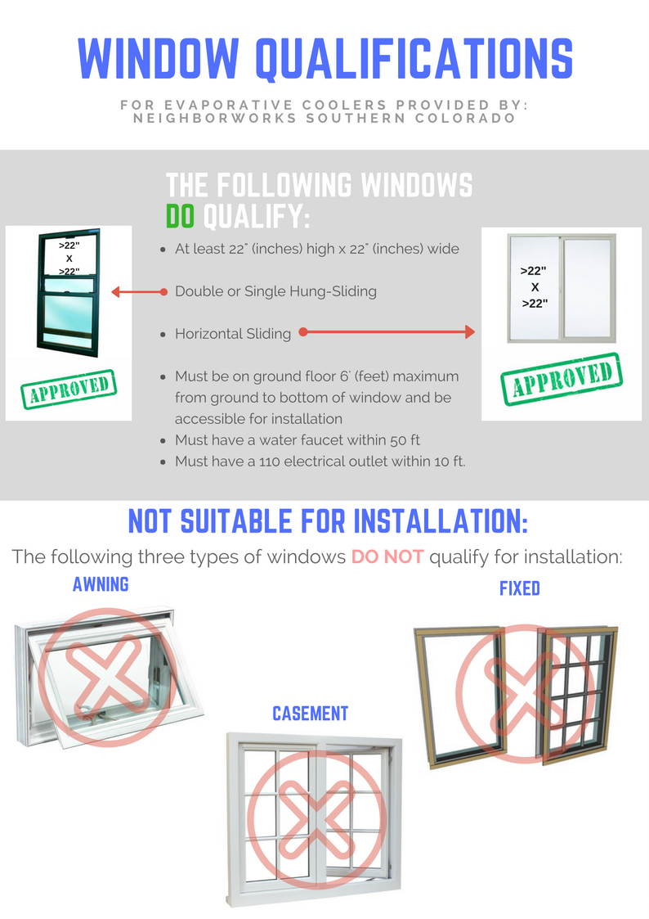
EXAMPLE OF ACCEPTABLE WINDOWS FOR EVAPORATIVE COOLER

INSPECTION FORM TO INSTALL WATER HEATER BLANKET

KFNGHDOATFL;EWRJIOR
Using the picture below as a reference, please tell us the following information:

Manufacturer:

Capacity:

Model Number:

Serial Number:

Date of Manufacture:

Inner Tank warranty years:

Parts warranty years:

Note: There is a possibility that installing a blanket on your water heater may void its warranty. Please make sure your water heater is not in warranty before you ask for one to be installed.

With this information, it does appear that the water heater meets the guidelines: YES___________ NO____________
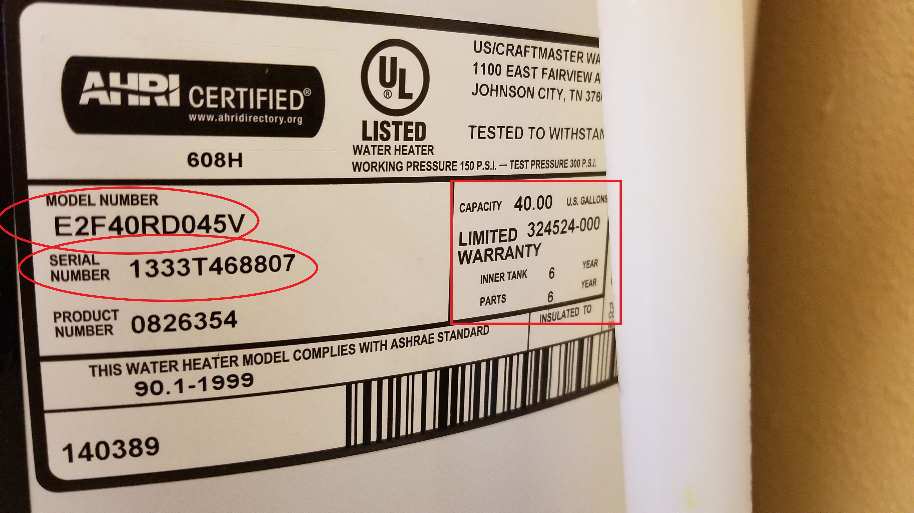

INSPECTION FORM TO INSTALL REFRIGERATOR
 APPLICANT CONTACT INFORMATION
DATE:__________________________

_______________________________ ( ) ( )
Last Name (please print) First Name (please print), MI Cell Phone Alternate Phone

___ Colorado
Street Address (please print) City State Zip
INFORMATION ON EXISTING REFRIGERATOR UNIT
(Applicant provides this information)
Is there an existing unit? | Yes _______ or No________
Is this the primary unit? | Yes ________ or No_________
Is this unit working? | Yes ________ or No_________
Manufacturer Name:
Model #:
Serial #:
Manufacture Date
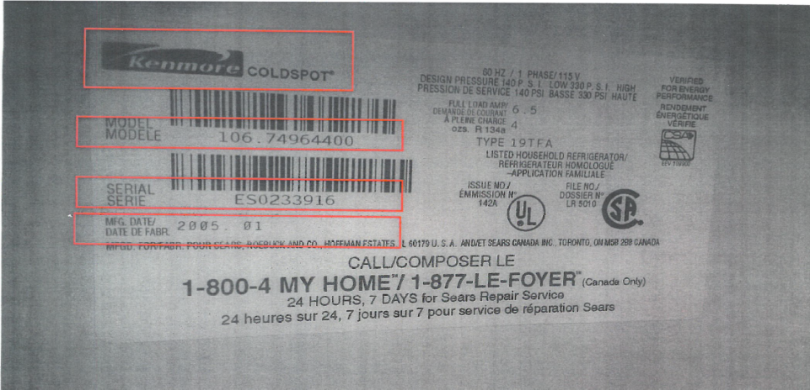

(NeighborWorks provides this information)
With this information, it does appear that the refrigerator meets the guidelines: YES___________ NO____________
(Attach this form to the forms sent to Lowes for Lowes to complete during installation)

LOWES’ REVIEW OF REFRIGERATOR PICKED UP
(Lowes provides this information)

Is the Refrigerator that Lowes picked up the same as the information above?_________________
Is the Refrigerator in the home the Primary unit?________________________________________
If answers are Yes, OK to Deliver
If answers are NO, DO NOT DELIVER

